*Noah Kamphuisen, Twan Asselbergs*

*HashWorks | Happy Herbivore*

*Functioneel Ontwerp*

05-02-2025

Table of Contents

Introduction 1

Purpose 2

Target Audience 3

Functional Requirements 4

UX Design 5

Wireframe 6

What Isn’t Included 7

**Introduction**

A new startup called ‘Happy Herbivore’ is opening a vegetarian/vegan fast-food restaurant in Hoog Catharijne, Utrecht. They want to run a self-service system as a pilot, but need help from a team of freelancers, because their internal development team is understaffed.

**Purpose**

Like many restaurants in this area, this restaurant is going to use a self service kiosk system, that we are developing for Happy Herbivore. For this reason, and to compete with other local restaurants, they also have to use a kiosk. It’s also very busy around Hoog-Catharijne, so a kiosk system is also a way for the staff to not be under constant stress from the many clients they expect to come in. Next to that, it’s also a good investion in the long term because it will alllow them to have less staff working in the restaurant at one time, saving costs.

**Target Audience**

The target audience for this restaurant is primarily young people from Utrecht that are looking for a fast, healthy, affordable, and most importantly: a vegan/vegetarian meal.

**Functional Requirements**

There are a few functional requirements for this self service kiosk system. In summary, we have to develop a fully functional protoype for a self service kiosk that is going to be used to pilot the first Dutch Happy Herbivore restaurant. We have to build an attractive idle mode that shows different menu items, think of it like a carousel. The start screen must contain the company logo and has to be readable from longer distance. Like mentioned earlier, the menu items have to rotate to attract the attention of passing customers.

We have to make sure to respect the hardware and tech specifications, which we have received from our client. Next to respecting the hardware specifications, we have to make sure to implement all of Happy Herbivore’s menu items, and fuse in their corporate identity. In terms of a payment process, we could simulate it. Eventually, a payment solution partner will be chosen, allowing us to implement it fully.

There are also some optional features, which are up to us if we want to integrate them or not. First of, a language selection feature. This will allow the user to select either Dutch or English for the kiosk. Secondly, we could add data to the menu, allowing the user to toggle between vegetarian and vegan menu items. Last but not least, we could add fields to the database. This means that after ordering, the order will have its preparation status shown.

**UX Design**

Looking at similar companies, we noticed that most brands have a modern and innovative design language, because they want to stand out. However, we do not think this is well-suited for a fast-food self-service system, because most people in a hurry do not want to think about how to navigate the screen. Instead, we will use a modern UI, with traditional UX to make the process as intuitive as possible.

**Wireframe**

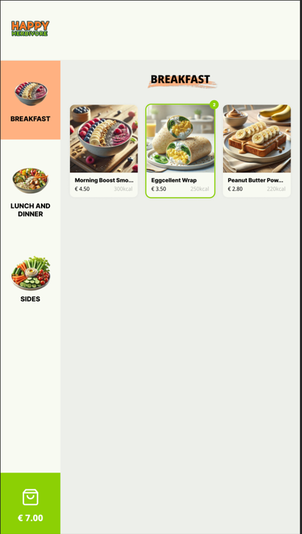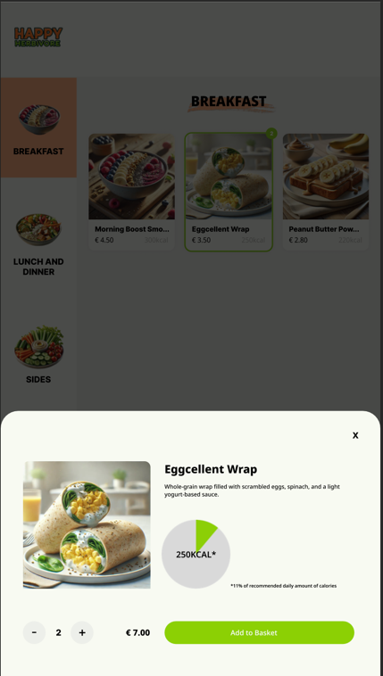

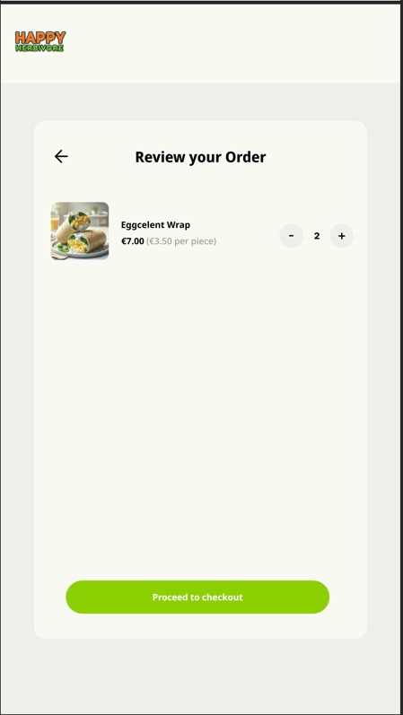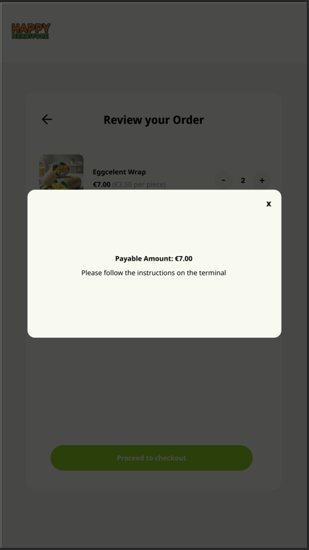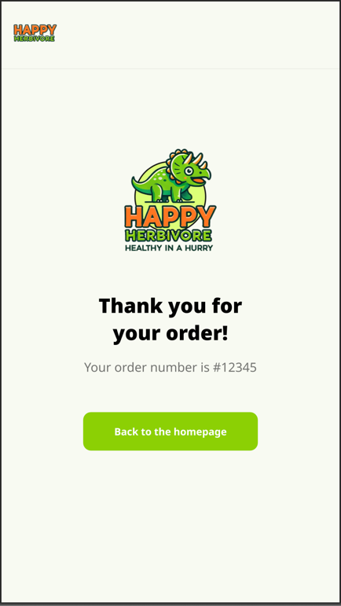

**What Isn’t Included**

Things that will not be included in the result: The payment system. We will simulate this using a timeout for the demo.  
Technical support for issues with hardware, we only provide the software. A content management system, for adding, removing, or editing products.